IMPLEMENT LINEAR REGRESSION

AIM:
To implement a Linear Regression model using Python to predict students' marks based on the number of hours studied and evaluate the model using Mean Squared Error (MSE) and R² Score.

ALGORITHM:
- Import the required libraries: Pandas, Matplotlib, Scikit-learn.
- Load the dataset from the data.csv file.
- Select Hours_Studied as the input feature and Marks as the target variable.
- Split the dataset into training and testing sets.
- Create a Linear Regression model.
- Train the model using the training dataset.
- Predict students' marks using the testing dataset.
- Evaluate the model using Mean Squared Error and R² Score.
- Display the predicted marks.
10.Plot the actual data and regression line using matplotlib.

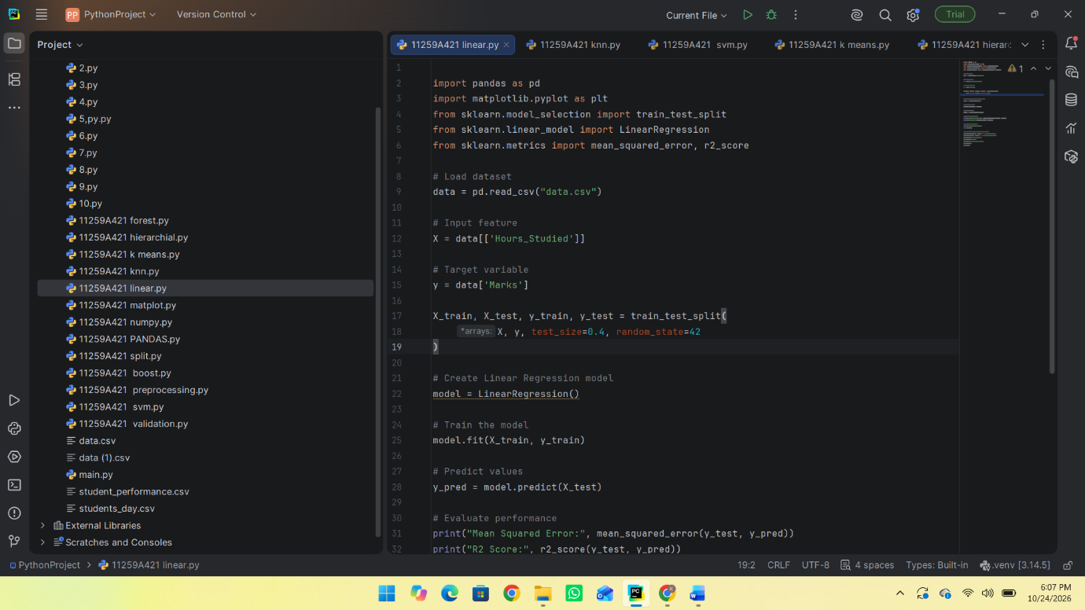
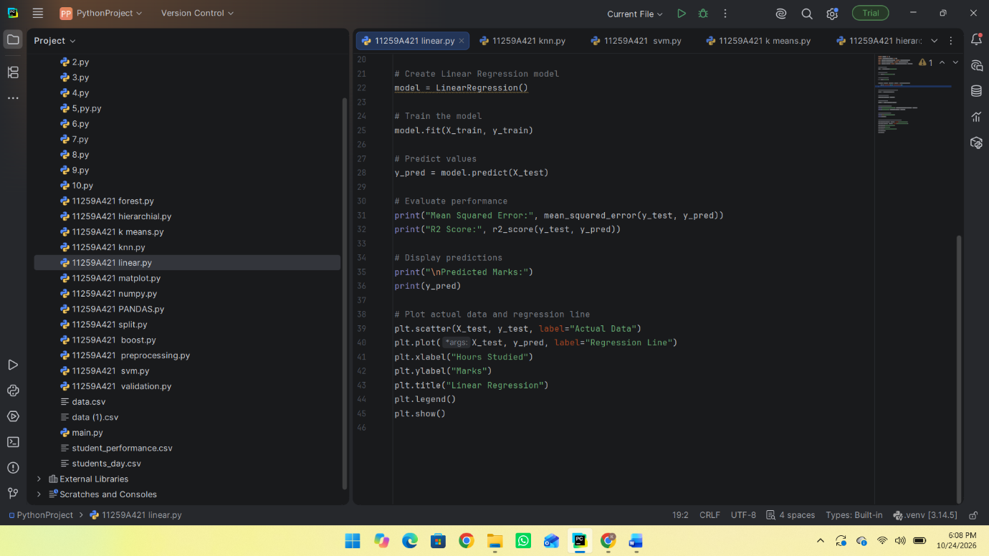
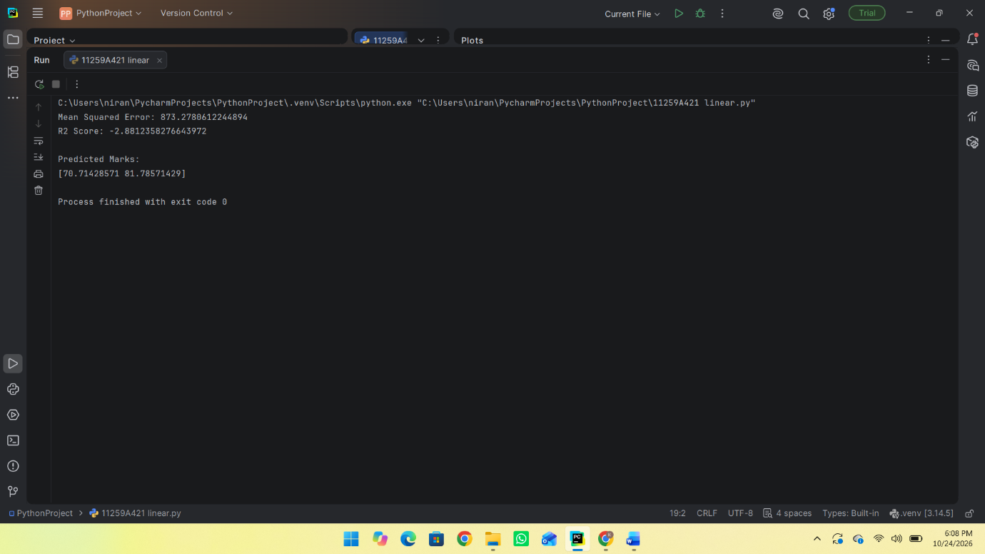
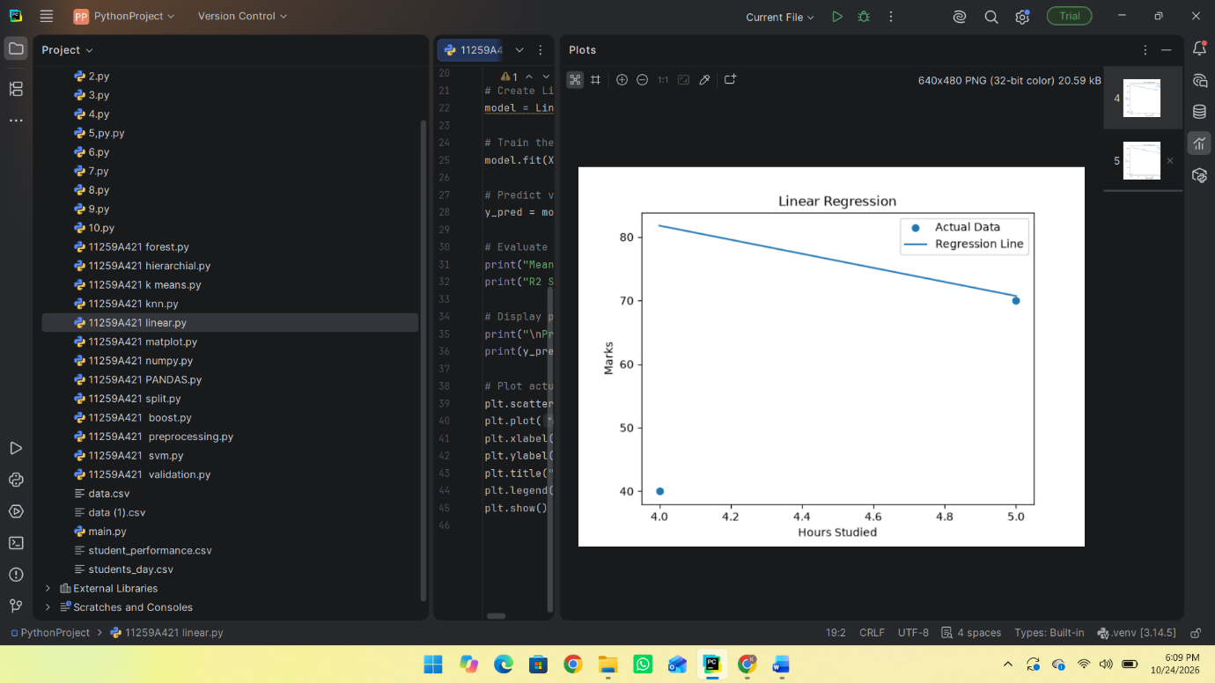

RESULT:
Thus, the Linear Regression model was successfully implemented in Python to predict students' marks based on hours studied.

